1st Grade News
News for October 28-November 1, 2013
Language Arts Corner  *Daily 5 - Comprehension and  Accuracy Strategies;  * Asking and Telling Sentences  *Beginning, Middle, End  New Sight words: we, I on, look, for | Social Studies Corner  * Community: Community Helpers  (continued)  *Look for information in your child’s folder about a special Community Helper Homework Project for this week.
Math Corner  *Problem Solving  *Equal Parts  *Making Shapes and Designing Quilts  *Bat Measurement | Science Corner  *Investigating Matter: Bat Measurement

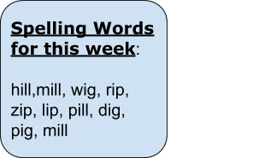
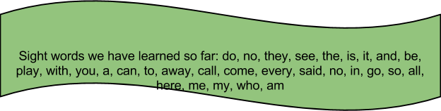

Book bags:

***First Graders are off to a great start reading the books in their book bags each night! Thank you for helping to log the books read each night and ensure that the book bag is returned to class each day. We are already observing students become voracious readers as they consistently practice reading and implement the strategies taught in class.

Hebron Elementary Night (Football Game):
Hebron Football is excited to welcome Indian Creek to
a home game, and have made plans to make the night
special for Future Hawks!!
November 1, 2013
“Spook the Lewisville Farmers”
Students, parents and teachers come dressed in your favorite
costume for the game against the Lewisville Fighting
Farmers!!

Hebron High School Turkey Tennis Camp:
November 25th-26th
11AM-1:30PM
Open to ALL students grades K-8

Camp Objective
Our goal is to ensure that each camper has a great time while developing the fundamentals of tennis. We will work to improve individual skills along with game strategy. Special attention will be given to help each camper gain self-confidence, a positive mental attitude, and motivation. Hebron Tennis Camps are a great opportunity to meet the coaches as well current and former high school players.
Camp Features
Individual Work & Attention
Contests
Awards
Campers will receive a Camp T-Shirt
Hebron Tennis Camps are led by Varsity Head Tennis Coach CJ Cowgill. Coach Cowgill is a certified tennis professional and has 12 plus years of coaching experience. Coach Cowgill is in his 7th season at Hebron HS. Other staff members include certified teaching pro’s, as well as champ and super-champ level players.
Camp Application
Please mail this form and a $45 check payable to:
CJ Cowgill
12771 Alfa Romeo Way
Frisco, TX 75033
(682)433-9271
T-Shirt Size
Youth S M L Adult S M L XL
Grade Age
I understand that I will assume any responsibility for expenses incurred as a result of any accident which happens during camp or on camp grounds while attending Hebron Tennis Camp… There will be no refunds given due to weather.
Name
Address
Email Address
Cell #
Guardian Name

